Celebration of Life in Christ

**Marlys Christine Mackenthun Meyers**

**Funeral Service**

**December 1, 1935 – November 6, 2020**

**Baptism December 15, 1935 – Confirmation April 10, 1949**

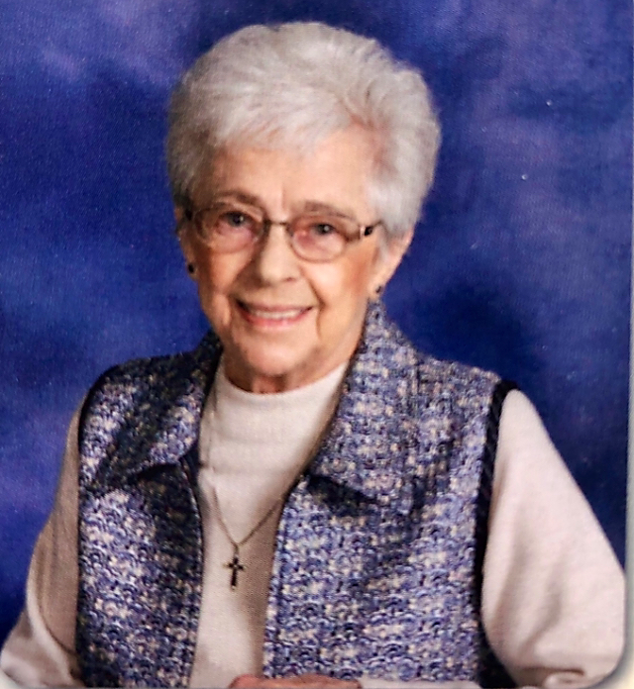

**Holy Cross Lutheran Church**

**Prior Lake, Minnesota**

**November 14, 2020 – 11:00 AM**

**† IN NOMINE JESU †**

***(In the Name of Jesus)***

**PRE-SERVICE MUSIC**

**BELL TOLL**

**ENTRANCE HYMN “Children of the Heavenly Father”** *LSB 725 vs 1-4*

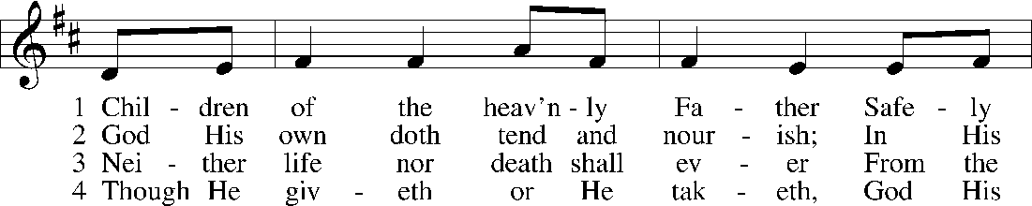

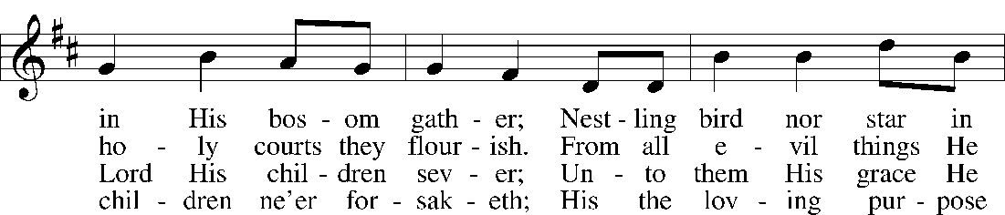

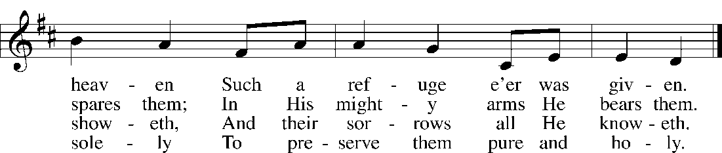

© Augsburg Publishing House. Used by permission: LSB Hymn License .NET, no. 100013743. Public domain

**INVOCATION**

P: In the name of the Father and of the **†** Son and of the Holy Spirit.

**C: Amen.**

**GREETING**  *1 Peter 1:3-4*

P: Praise be to the God and Father of our Lord Jesus Christ! In His great mercy He has given us new birth into a living hope through the resurrection of Jesus Christ from the dead, and into an inheritance that can never perish, spoil, or fade---kept in heaven for you.

**C: Amen.**

**REMEMBRANCE OF BAPTISM**  *Romans 6:3-5*

P: In Holy Baptism Marlys Christine Mackenthun Meyers was clothed with the robe of Christ's righteousness that covered all her sin. St. Paul says, "Do you not know that all of us who have been baptized into Christ Jesus were baptized into His death?"

**C: We were buried therefore with Him by baptism into death, in order that, just as Christ was raised from the dead by the glory of the Father, we too might walk in newness of life. For if we have been united with Him in a death like His, we shall certainly be united with Him in a resurrection like His. Alleluia!**

**PSALMODY** *Psalm 23* *(KJV)*

P: The Lord is my shepherd;

**C: I shall not want.**

P: He maketh me to lie down in green pastures;

**C: He leadeth me beside the still waters.**

P: He restoreth my soul;

**C: He leadeth me in the paths of righteousness for his name's sake.**

P: Yea, though I walk through the valley of the shadow of death, I will fear no evil: for thou art with me.

**C: thy rod and thy staff, they comfort me.**

P: Thou preparest a table before me in the presence of mine enemies:

**C: Thou anointest my head with oil; my cup runneth over.**

P: Surely goodness and mercy shall follow me all the days of my life:

**C: and I will dwell in the house of the Lord forever. Glory be to the Father and to the Son and to the Holy Spirit; as it was in the beginning, is now, and will be forever. Amen.**

**OLD TESTAMENT** *Psalm 121:1-8*

*(The Lord is always watching over our life.)*

1I lift up my eyes to the hills. From where does my help come? 2My help comes from the Lord, who made heaven and earth. 3He will not let your foot be moved; he who keeps you will not slumber. 4Behold, he who keeps Israel will neither slumber nor sleep. 5The Lord is your keeper; the Lord is your shade on your right hand. 6The sun shall not strike you by day, nor the moon by night. 7The Lord will keep you from all evil; he will keep your life. 8The Lord will keep your going out and your coming in from this time forth and forevermore.

P: This is the Word of the Lord. **C: Thanks be to God.**

**EPISTLE** *Ephesians 2:4-10*

*(It is by grace you have been saved.)*

4But God, being rich in mercy, because of the great love with which he loved us, 5even when we were dead in our trespasses, made us alive together with Christ—by grace you have been saved— 6and raised us up with him and seated us with him in the heavenly places in Christ Jesus, 7so that in the coming ages he might show the immeasurable riches of his grace in kindness toward us in Christ Jesus. 8For by grace you have been saved through faith. And this is not your own doing; it is the gift of God, 9not a result of works, so that no one may boast. 10For we are his workmanship, created in Christ Jesus for good works, which God prepared beforehand, that we should walk in them.

P: This is the Word of the Lord. **C: Thanks be to God.**

**HOLY GOSPEL** *John14:1-6*

P: The Holy Gospel according to St. John, the fourteenth chapter. **C: Glory to You, O Lord.**

*(Jesus prepares a place for us in heaven. He is the way, the truth and the life.)*

1[Jesus said:] “Let not your hearts be troubled. Believe in God; believe also in me. 2In my Father’s house are many rooms. If it were not so, would I have told you that I go to prepare a place for you? 3And if I go and prepare a place for you, I will come again and will take you to myself, that where I am you may be also. 4And you know the way to where I am going.” 5Thomas said to him, “Lord, we do not know where you are going. How can we know the way?” 6Jesus said to him, “I am the way, and the truth, and the life. No one comes to the Father except through me.

P: This is the Gospel of the Lord. **C: Praise to You, O Christ.**

**SERMON HYMN “Just as I am Without One Plea”** *LSB 570 vs 1-6*

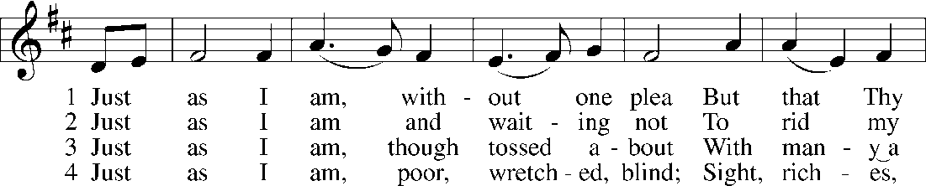

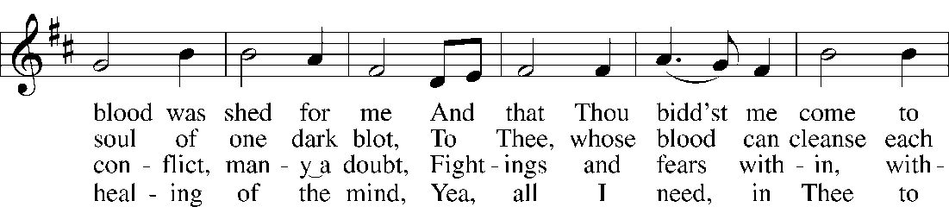

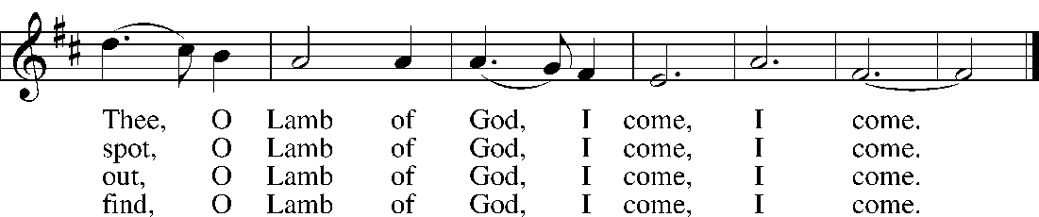

**5 Just as I am, Thou wilt receive, Wilt welcome, pardon, cleanse, relieve;  
Because Thy promise I believe, O Lamb of God, I come, I come.**

**6 Just as I am; Thy love unknown Has broken ev’ry barrier down;  
Now to be Thine, yea, Thine alone, O Lamb of God, I come, I come.**

Public domain

**SERMON**  **B**asic **I**nstructions **B**efore **L**eaving **E**arth *Rev. James Jobst*

(The Living Word – The Way to Happiness)

**Marlys’ Confirmation verse:** Ps. 26:8 **Favorite verses:** Neh. 8:10b; Eph. 2:8; Ro. 12:12; Rev. 2:10b; Psalm 51

**REFLECTION HYMN “Abide with Me”** *LSB 878 vs 1-6*

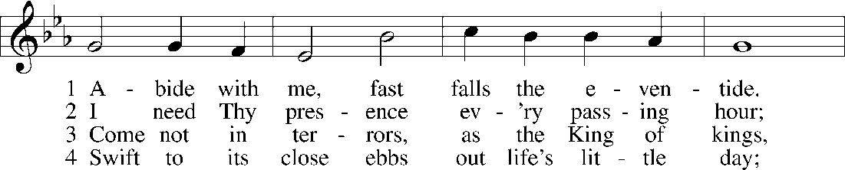

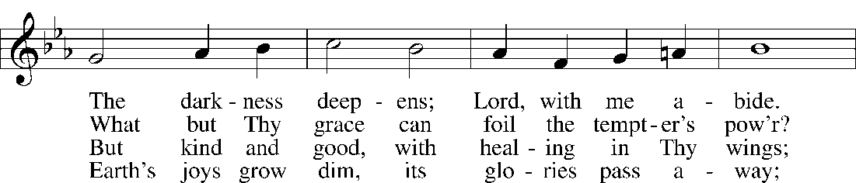

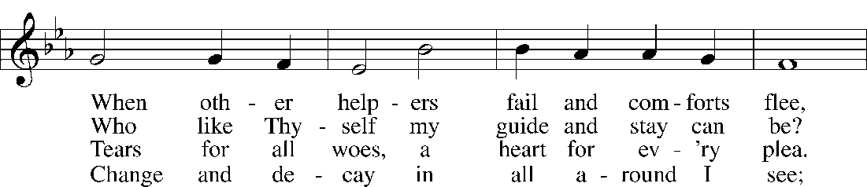

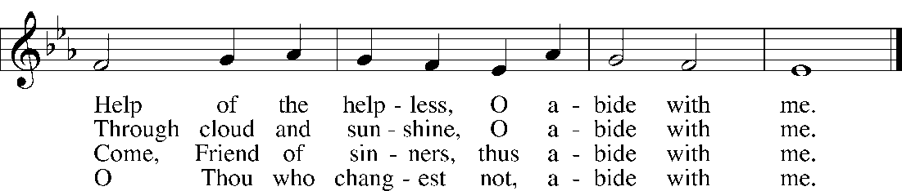

**5. I fear no foe with Thee at hand to bless; Ills have no weight and tears no bitterness.  
Where is death’s sting? Where, grave, thy victory? I triumph still if Thou abide with me!**

**6. Hold Thou Thy cross before my closing eyes; Shine through the gloom, and point me to the skies.  
Heav’n’s morning breaks, and earth’s vain shadows flee; In life, in death, O Lord, abide with me.**

Public domain

**THE PRAYERS –** *(After the petition, the Pastor prays “Lord in your mercy,” the congregation prays, “Hear our prayer.”)*

P: Let us pray to the Lord, our God and Father, who raised Jesus from the dead.

P: Almighty God, You have knit Your chosen people together into one communion in the mystical body of Your Son, Jesus Christ, our Lord. Give to Your whole Church in heaven and on earth Your light and peace. Lord, in Your mercy,

**C: hear our prayer.**

P: Grant that all who have been baptized into Christ's death and resurrection may die to sin and rise to newness of life and so pass with Him through the gate of death and the grave to our joyful resurrection. Lord, in Your mercy,

**C: hear our prayer.**

P: Grant that all who have been nourished by the holy body and blood of Your Son may be raised to immortality and incorruption to be seated with Him at Your heavenly banquet. Lord, in Your mercy

**C: hear our prayer.**

P: Give to the family of Marlys and to all who mourn comfort in their grief and a sure confidence in Your loving care that, casting all their sorrow on You, they may know the consolation of Your love. Lord, in Your mercy,

**C: hear our prayer.**

P: Give courage and faith to the bereaved, that within the communion of Your Church they may have strength to meet the days ahead in the assurance of a holy and certain hope and in the joyful expectation of eternal life with those they love who have departed in the faith. Lord, in Your mercy,

**C: hear our prayer.**

P: Help us, we pray, in the midst of things we cannot understand, to believe and find comfort in the communion of saints, the forgiveness of sins, the resurrection of the body, and the life everlasting. Lord, in Your mercy,

**C: hear our prayer.**

P: Receive our thanks for Marlys and for all the blessings You bestowed on her in this earthly life. Bring us at last to our heavenly home that with her we may see You face to face in the joys of paradise. Lord, in Your mercy,

**C: hear our prayer.**

P: O God of all grace, You sent Your Son, our Savior Jesus Christ, to bring life and immortality to light. We give You thanks that by His death He destroyed the power of death and by His resurrection He opened the kingdom of heaven to all believers. Strengthen us in the confidence that because He lives we shall live also, and that neither death nor life nor things present nor things to come will be able to separate us from Your love, which is in Christ Jesus, our Lord, who lives and reigns with You and the Holy Spirit, one God, now and forever.

**C: Amen.**

**THE LORD’S PRAYER**

P: Taught by our Lord and trusting His promises, we are bold to pray:

**C:** **Our Father who art in heaven, hallowed be Thy name, Thy kingdom come, Thy will be done on earth as it is in heaven; give us this day our daily bread; and forgive us our trespasses as we forgive those who trespass against us; and lead us not into temptation, but deliver us from evil. For Thine is the kingdom and the power and the glory forever and ever. Amen.**

**BENEDICTION**

P: As you go on your way, may God go with you. May He go before you to show you the way. May He go behind you to encourage you. Beside you to befriend you. Above you to watch over you. And within you to give you peace. In the name of the Father, and of the **†** Son, and the Holy Spirit

**C:** **† Amen. †**

**SENDING HYMN “On Eagles’ Wings”** *LSB 727*

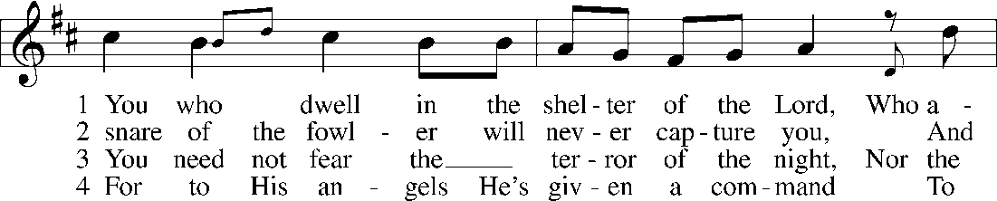

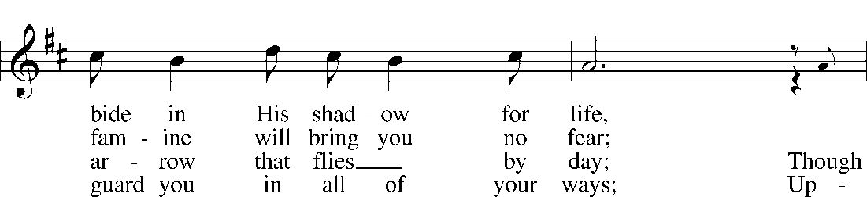

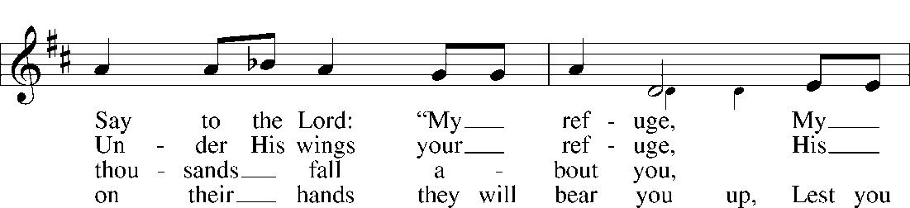

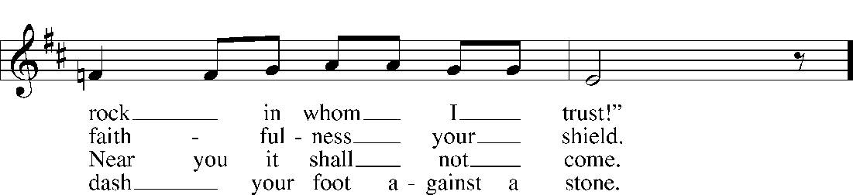

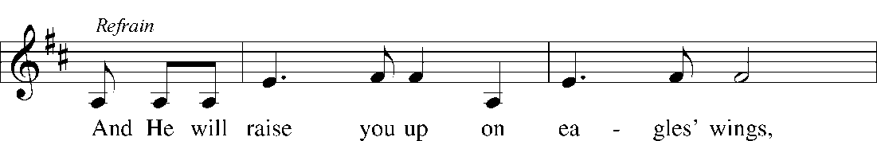

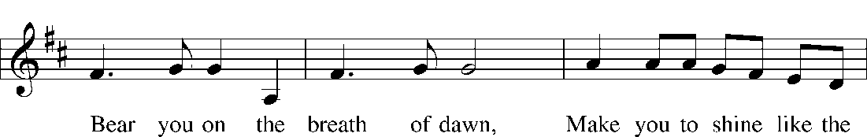

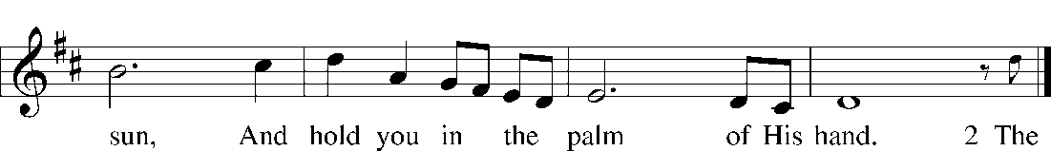

© OCP Publications. Used by permission: LSB Hymn License .NET, no. 100013743.

**POSTLUDE**

**† SOLI DEO GLORIA †**

*(To God be the Glory)*

*+++++++++++*

**PALLBEARERS**

**Bill Mackenthun James Mackenthun**

**Jon Mackenthun Marc Mackenthun**

**Michael Mackenthun Dallas Hixson**

**SERVING IN THE HOUSE OF THE LORD TODAY**

**Organist: Mui Cheng**

**AV: Jason Eickhoff**

**Recording: Michael Hentges**

**Officiant Rev. James Jobst**

**Memorials may be made to Holy Cross Lutheran Church**

**Marlys’ family gives thanks to the Lord for the prayers, love, and support during this time. It means so much to us! Thank you! Thank you also for the Memorials given for building needs at Holy Cross. (No formal thank you cards will be sent.)**

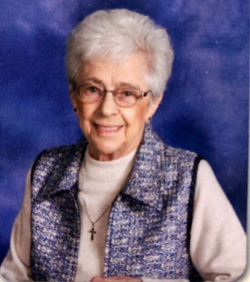**Marlys Christine Mackenthun Meyers**

**On Thursday, November 6, 2020 the Lord of life and death granted eternal rest to His servant, Marlys Christine Mackenthun Meyers at the age of 84 years.**

**On December 1, 1935, Marlys was born to parents Herb and Christine (Bathen) Mackenthun in Glencoe, MN. She was baptized into the Christian faith on December 15, 1935 and confirmed on April 10, 1949 at First Evangelical Lutheran Church in Glencoe, MN.**

**On May 5, 1979, Marlys exchanged wedding vows with Warren Meyers in Richfield, MN. They were blessed with 28 years together. They lived in Richfield before moving to Savage, MN in 1994.**

**Marlys graduated in 1953 from Glencoe High School and continued her education at Concordia College in St. Paul, MN. She later taught school in Texas and Minnesota for five years before entering the business world and working in the insurance industry. Marlys spent over 30 years employed with Satellite Industries.**

**After retiring, Marlys began to volunteer at the Bethesda Thrift Store. She dedicated over 20 years at Bethesda doing the Greeting Card Section. She received a 2,500-hour badge for her weekly commitment at Bethesda. She had to stop volunteering in March of this year due to the Covid-19 pandemic. For several years, Marlys also served as church Treasurer while a member of Holy Cross Lutheran Church.**

**Marlys is survived by her many nieces, nephews, and sisters-in-law, Nancy Mackenthun, Jan Meyers, and Edie Meyers. She is reunited in Heaven with her husband, Warren; brothers, Marvin Mackenthun, Vernon Mackenthun, Lorenz Mackenthun; brothers-in-law, Richard Meyers, Arthur (Barbara) Meyers, and Walter Meyers; nephew Tom Mackenthun.**

**Pallbearers are Bill Mackenthun, James Mackenthun, Jon Mackenthun, Marc Mackenthun, Michael Mackenthun, and Dallas Hixson.**

**The funeral service is Saturday, November 14, 2020 at 11AM with a visitation 1-hour prior at Holy Cross Lutheran Church, 14085 Pike Lake Trail NE, Prior Lake, MN. Reverend James Jobst will preside.**

**Marlys will be laid to rest at Fort Snelling National Cemetery, Monday, November 16, 2020,**